NM3217 Semester 2, AY15/16

Organisation Research and Strategic Plan



Chng Xinni (A0100189M)

# Chosen Organisation

My chosen organisation is Singapore’s **Health Promotion Board** **(HPB)**.

## Background

The Health Promotion Board (HPB) was established in 2001 (HPB, Health Promotion Board Singapore, 2012). It has since assumed the role of the main instigator for national health promotion and disease prevention programmes. Though Singaporeans enjoy relatively good health, high life expectancies and low mortality rates, HPB aims to further improve the health status of Singaporeans. (HPB, 2014)

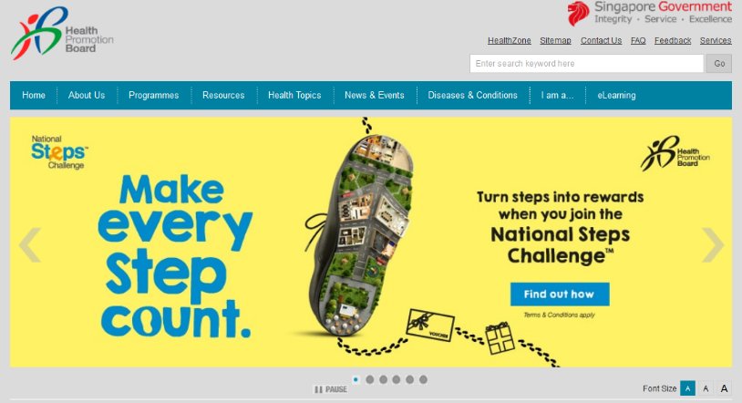HPB’s website, [www.hpb.gov.sg](http://www.hpb.gov.sg), is the home of information related to HPB, such as news, events, contact information and programmes. It is also home to HPB’s resources, which include educational videos and publications on health in Singapore. The website is an information hub for Singaporeans, containing an alphabetical catalogue of disease and conditions, and articles on various health topics, such as weight management, pregnancy, student health and eye care.

## Programmes and Key Publics

HPB implements **programmes** that reach out to the population, so their key publics include Singaporean children, adults and the elderly. Their target audiences depend on the individual programme. For example, their Mental Wellness programmes target tertiary institutions; they include talks, workshops and skits aimed at students in ITEs, polytechnics and universities (HPB, Mental Wellness programmes for tertiary institutions / IHLs , 2012). Their Oral Health Promotion Programme, which raises public awareness of the importance of oral health, is aimed at the general adult population (HPB, Adult Oral Health Promotion Programme , 2012).

## Vision and Mission

HPB’s **vision** is to build a nation of healthy people.

HPB’s **mission** is “Empowering individuals to take ownership of their health”, by being a centre of excellence for health promotion, disease prevention and patient education, and also by engaging and supporting local and international partnerships, and lastly, by being a people-centred organisation that inspires and enables their employees to realise their full potential. (HPB, 2014)

## Goals and Objectives

Two main goals of HPB are

1. To increase the quality and years of healthy life and

2. To prevent illness, disability and premature death in Singaporeans. (HPB, 2014)

## Organisation Structure

HPB is split into multiple divisions which are made up of smaller departments.

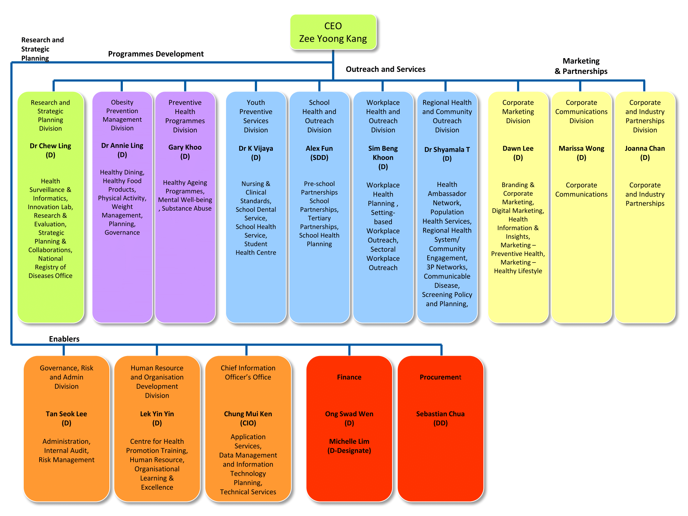

*Diagram from HPB* [*organizational chart*](http://www.hpb.gov.sg/HOPPortal/content/conn/HOPUCM/path/Contribution%20Folders/uploadedFiles/HPB_Online/About_HPB/Organisation_Structure/HPBOrgChartDec15.pdf)(HPB, Organisation Structure, 2015)*.*

Leading the organization are HPB’s board of directors and senior management, with Mr Lucas Chow heading HPB as Chairman and Mr Zee Yoong Kang as CEO (HPB, Board of Directors and Senior Management, 2015).

Each division spearheads the health programs that are under it. For example, the Obesity Prevention Management Division is in charge of the Healthy Dining program. A complete table of divisions and departments can be found in the *Appendix, Section 7.1*.

# Public Relations Opportunity

## The Problem

HPB has deployed a myriad of programmes which has attempted to address many health issues that Singaporeans face, ranging from healthy eating programmes to smoking control programmes. However, further analysis of HPB’s programmes and publications led to a discovery of the lack of initiatives targeted at Singapore’s sleep-deprived population.

HPB has no programmes to address this issue and a search of their website nets only two short articles on sleep – one 175-word general article on sleep (HPB, Sleep, 2012) with tips and another article for schoolers with similar tips for good sleep (HPB, 6 Tips to Avoid Back-To-School Panda Eyes, 2015).

Meanwhile, several local news articles and expert publications have stressed the seriousness of this health issue. Singapore is the 3rd most sleep-deprived nation in the entire world, clocking an average of 6 hours and 32 minutes of sleep daily, less than the recommended minimum of 8 hours (Chong, 2015). Sleep deprivation can lead to physical accidents, cognitive and learning impairment, chronic diseases, lowered libido, clinical depression, rapid ageing and even death. (Chong, 2015)

Dr Chong Yaw Khian, head of the Snoring and Sleep Apnoea Clinic at Tan Tock Seng Hospital, attributes working adults and teenagers’ lack of sleep to long working hours, stresses of daily life, constant distractions and sometimes, medical conditions.

## Key Publics and How To Address Them

In this section, we will pinpoint two key publics most affected by sleep deprivation, which will also help us break down the main issue into smaller issues pertaining to that particular key public. Information on other publics can be found under *Additional Information, Section 5.2*.

### Key Public 1 – Working Adults

One possible key public that may be targeted is Singaporean working adults aged 25 - 59. As of 2013, there are 1.84 million working Singaporeans in that age range, and they make up 86% of the labour force. (Ministry of Manpower, 2013)

Many Singaporeans in this category are getting inadequate sleep. A survey of 1,000 Singaporeans between the ages of 20 and 59 by research firm 2CV reported that over 80% of Singaporeans sleep less than 8 hours each night (Kurohi, 2015).

Several analysts have linked their lack of sleep to the well-established culture of working long hours. In a 2011 survey of 95 employees, 20% of Singapore workers worked more than 11 hours a day (Goh, 2015). 65% of respondents in a Working Hours Survey in 2014 felt obligated to work in excess of office hours, bringing their work home (Evans, 2014).

Hence, HPB’s publications targeting this key public should focus on encouraging them to reduce their working hours and, instead of bringing work home, make use of after work hours to relax and unwind.

### Key Public 2 – University Students

Local university students aged between 18 and 30 years old is another suitable key public. According to a study of 2,000 college students at the National University of Singapore and the Nanyang Technological University, college students sleep an average of 6.2 hours, less than the recommended 7 - 9 hours (Khalik, 2013).

This lack of sleep has led to health issues in college students. Dr Peter Yeo, a senior physician at NTU Medical Centre, cited his encounters with students who suffered headaches and nausea after pulling all-nighters for exams and projects. NTU physician Tjioe Yan Yin also mentioned stress from school and excessive laptop and phone usage as common causes of sleep deprivation in students (The NTU Magazine, 2014).

Therefore, HPB’s publications with university students as their target audience should aim to discourage sacrificing sleep for school assignments and instead encourage and provide tips for a consistent and moderate work-life balance. They can also include resources for stressed students to help them manage stress. Lastly, these publications should persuade students to put aside their devices at night time to curb distractions that could affect falling asleep.

## The Proposed Solution

I propose a HPB programme with a behavioural **goal**: to persuade sleep-deprived Singaporeans to modify their lifestyles and attain adequate sleep.

The programme aims to achieve this by educating Singaporeans on the importance of sleep and the dangers of sleep deprivation, and by equipping them with practical tips on getting good sleep. The programme will get Singaporeans to sign an online pledge to obtain their daily recommended 7-9 hours of sleep every night (National Sleep Foundation, 2015).

# Strategic Plan

This strategic plan consists of three main publications – a flyer, brochure (folder) and website - that collectively aim to achieve the programme’s goal of getting Singaporeans to get their recommended daily hours of sleep. The series of publications will be targeted at 2 key publics affected by sleep deprivation mentioned previously – working adults and university students.

The plan will be launched on World Sleep Day, which falls on 18 March 2016, and the collection of online pledges will commence. The **objective** of the plan is 10,000 total online pledges by 1 June 2016. Two months are estimated to complete the distribution of fliers and folder and advertising of the website.

## Flier Distribution

|  |  |
| --- | --- |
| Objective | To attain 2,000 university student online pledges on programme website by 1 June 2016 |
| Target Audience | University students |
| Information | * A catchy and relatable header and imagery (related to lack of sleep) to grab attention of students * A brief paragraph to raise awareness on the issue of sleep deprivation, importance of sleep and a prompt to encourage students to check out the programme website to find out more about the programme, seek resources on managing stress and sign a pledge. * A short URL and scannable QR code that both lead to the programme website |
| Place of distribution | These complimentary fliers will be distributed on local university campuses to students. Some suggested places include bus stops, where students awaiting buses may read them. |
| Rationale | Fliers are cheap to mass produce and easy to distribute to population-dense campuses. |
| How to evaluate | The links to the website on the flyer can be modified specially to indicate that the person arrived on the website from the flyer. From website analytics, one can track how many pledges were made by students who read the flyer. We can also check the database of pledges to see that 2,000 university students have pledged. |

## Brochure Distribution

|  |  |
| --- | --- |
| Objective | To attain 8,000 working adult online pledges on programme website by 1 June 2016 |
| Target Audience | Working adults |
| Information | * A catchy and relatable title and image to grab attention of overworked and sleep deprived adults * Raise awareness of overworking and sleep deprivation in Singapore, and how it affects quality of sleep and consequently, health * A checklist guide to help the reader identify if they are sleep deprived * The importance of sleep and dangers of not getting enough sleep * Brief tips on getting good sleep * A prompt to the reader to check out the programme website to find out more about the programme, seek resources on managing a work-life balance and sign a pledge. * A short URL and scannable QR code that both lead to the programme website |
| Place of distribution | * Inside office pantries, a frequent place of visit from workers who head there to grab beverages or take a short break * On brochure stands of clinics, office lobbies and other areas with high volume of working adults passing by. |
| Rationale | Brochure distribution is a more formal mode of distribution suitable for working class adults.  HPB can also form partnerships with corporations and health organizations who run offices, malls and clinics where the brochures can be distributed. |
| How to evaluate | The links to the website on the flyer can be modified specially to indicate that the person arrived on the website from the brochure. From website analytics, one can track how many pledges were made by working adults who read the brochure. We can also check the database of pledges to see that 8,000 working adults have pledged. |

## Website

|  |  |
| --- | --- |
| Objective | To attain 10,000 total online pledges by 1 June 2016 |
| Target Audience | University students and working adults |
| Information | * A cross-browser compatible, responsive website on a reliable server with near 100% uptime for maximum accessibility across devices. The website should have intuitive navigation, well-written articles and delightful visuals to keep visitors enticed and encourage return visits. Design must be mobile-first, as readers of the flyers and brochures are most likely accessing the site on their phones. A well-designed website with good use of typography, color and illustrations will be perceived as credible to the public. * Comprehensive description of the situation of sleep deprivation in Singapore, the importance of sleep and dangers of sleep deprivation. * Inspiring interviews with successful individuals similar to key publics who manage work-life balance and rested sleep, so that readers may resonate with their stories and feel motivated * Practical, actionable lifestyle tips to getting a good night’s rest catered to working adults and university students respectively; this knowledge is aimed to increase their self-efficacy, which is essential for instigating behavioural change (Fogg, 2009). * An online form for readers to take a pledge to get at least 7-9 hours of sleep per night. |
| Place of distribution | On the web, hosted on a Singaporean server for faster access. It can be advertised on social media and linked from HPB’s programme catalogue. |
| Rationale | Publics merge in cyberspace. Anyone with an internet connection will be able to reach the resources offered on the programme website.  A website can contain more information than a printed publication, and may be accessed conveniently in many devices.  Many custom functionalities can be programmed on the web. One important example is the pledge sign-up system. |
| How to evaluate | 10,000 online pledges reached. The database of pledges can be queried to check that the goal has been obtained. |

# Evaluation of Plan

To evaluate the overall success of the plan, we will check the number of pledges obtained from the database to see that the goal of 10,000 has been reached.

To measure the extent of behavioural change, we can conduct a pre-campaign survey to ask working adults and university students respectively about their sleeping hours and lifestyle habits. A post-campaign survey can then be conducted on them to find out how many hours of sleep they are getting each night. Th­­­­e results can be compared with the results from previous survey to measure the effectiveness of the programme.

*End* *of Main Report ☺*

# Additional Info

## HPB’s website and critique

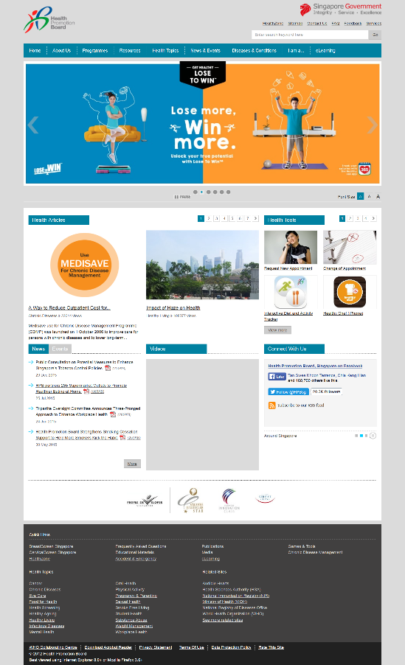­­­HPB’s website, [www.hpb.gov.sg](http://www.hpb.gov.sg), has a relatively modern adaptive design that scales on mobile, ensuring its accessibility regardless of device. The navigation is clear and well-labelled, inviting the users to find out more in ‘About Us’, providing information in ‘Programmes’, ‘Resources’ and ‘Health Topics’, and providing clear points of contact in ‘Contact Us’.

One area of improvement is the ‘Programmes’ page, which is presented as a long list of text links for the user to navigate to and find out more. A thumbnail gallery view with short descriptions of each programme would not only have been more visually appealing, it would have made discovering the organisation’s programmes easier and faster for the public. This will be important as this report’s proposed programme will be listed under the ‘Programmes’ page.

## Other publics

Here is a brief section on other publics that are also affected by sleep deprivation in Singapore, who are not included in the priority publics in order to keep the scope concise.

* **Primary school students**. A survey found that 37.5% of six to nine year-olds show signs of sleep deprivation. Side effects in this category include failing grades, inability to pay attention, anxiety and depression. (Yang, 2015)
* **Secondary school students**. A study of teenagers in six schools found that 80% of them were not getting the recommended 8 - 9 hours of sleep on school nights. Lack of sleep in teenagers leads to dampened creativity, stunted growth and emotional problems. (Khalik, 4 in 5 teens not getting enough sleep, 2009)
* **Sufferers of sleep disorders**. Sleep disorders such as sleep apnoea and chronic insomnia are associated with increased morbidity and other diseases. In an editorial by physicians from Singapore Neurology and Sleep Centre, a pressing need to raise awareness of sleep health issues to reduce undiagnosed and untreated sleep orders was raised. (Lim, 2008)

# References

Chong, Y. K. (2015). *Sleep Deprivation*. Retrieved from https://www.ttsh.com.sg/articles/sleep-deprivation/

Evans, A. (2014). *Working Hours Survey 2014 - Long working hours leads to a poor work-life balance for Singapore’s professionals*. Retrieved from http://www.morganmckinley.com.sg/article/working-hours-survey-2014-long-working-hours-leads-poor-work-life-balance-singapore%E2%80%99s

Fogg, B. (2009). *A Behavior Model for Persuasive Design.* Retrieved from http://bjfogg.com/fbm_files/page4_1.pdf

Goh, J. (2015). *Singapore workers put in long hours*. Retrieved from http://www.straitstimes.com/forum/letters-on-the-web/singapore-workers-put-in-long-hours

HPB. (2012). *Adult Oral Health Promotion Programme* . Retrieved from http://hpb.gov.sg/HOPPortal/programmes-article/4860

HPB. (2012). *Health Promotion Board Singapore*. Retrieved from Health Promotion Board: http://www.hpb.gov.sg/HOPPortal/

HPB. (2012). *Mental Health*. Retrieved from http://www.hpb.gov.sg/HOPPortal/healthtopic/Mental Health

HPB. (2012). *Mental Wellness programmes for tertiary institutions / IHLs* . Retrieved from http://www.hpb.gov.sg/HOPPortal/programmes-article/HPB035844

HPB. (2012). *Sleep*. Retrieved from http://hpb.gov.sg/HOPPortal/health-article/HPB039474

HPB. (2014). *About Us*. Retrieved from http://www.hpb.gov.sg/HOPPortal/faces/AboutUs

HPB. (2015). *6 Tips to Avoid Back-To-School Panda Eyes*. Retrieved from http://www.hpb.gov.sg/HOPPortal/breathe-article/HPB-047063

HPB. (2015). *Board of Directors and Senior Management*. Retrieved from http://www.hpb.gov.sg/HOPPortal/article?id=3772

HPB. (2015). *Healthy Eating Every Day*. Retrieved from http://www.hpb.gov.sg/HOPPortal/programmes-article/HPB063005

HPB. (2015). *Organisation Structure*. Retrieved from http://www.hpb.gov.sg/HOPPortal/faces/oracle/webcenter/portalapp/pages/AboutUs/AboutUsArticlePage/AboutUsArticlePage.jspx?articleTitle=Organisation%20Structure&articleFolder=/Contribution%20Folders/HPB%20Online/About%20HPB/&_afrLoop=118229413970733027&_af

Khalik, S. (2009). *4 in 5 teens not getting enough sleep*. Retrieved from http://www.sgh.com.sg/about-us/newsroom/News-Articles-Reports/2009/Pages/4-in-5-teens-not-getting-enough-sleep-The-Straits-Times,-Mon,-pg-B2--20090105.aspx

Khalik, S. (2013). Retrieved from http://www.straitstimes.com/singapore/lack-of-sleep-is-nothing-to-yawn-about

Kurohi, R. (2015). Retrieved from Sleep survey: Stress, smartphones stymie Singaporeans' sleep: http://www.straitstimes.com/singapore/health/sleep-survey-stress-smartphones-stymie-singaporeans-sleep

Lim, L. L. (2008). Sleep Disorders: Sleepless in Singapore. *Annals Academy of Medicine*, p. http://www.annals.edu.sg/pdf/37VolNo8Aug2008/V37N8p627.pdf.

Ministry of Manpower. (2013). *Labour Force in Singapore, 2013.* Retrieved from http://app.msf.gov.sg/Portals/0/Files/CEDAW/mrsd_2013LabourForce%20%282%29.pdf

National Sleep Foundation. (2015). *National Sleep Foundation Recommends New Sleep Durations*. Retrieved from https://sleepfoundation.org/media-center/press-release/national-sleep-foundation-recommends-new-sleep-times

The NTU Magazine. (2014). *Talk Sleep, not Sheep.* Retrieved from http://www.hey.ntu.edu.sg/issue14/pdf/HEY_jan_feb2014.PDF

Yang, C. (2015). *Many parents not alert to child's lack of sleep: Study*. Retrieved from http://www.straitstimes.com/singapore/many-parents-not-alert-to-childs-lack-of-sleep-study

# Appendix

## Divisions and Departments

This table can be found under [HPB’s website on Organisation Structure](http://www.hpb.gov.sg/HOPPortal/faces/oracle/webcenter/portalapp/pages/AboutUs/AboutUsArticlePage/AboutUsArticlePage.jspx?articleTitle=Organisation%20Structure&articleFolder=/Contribution%20Folders/HPB%20Online/About%20HPB/&_afrLoop=118229413970733027&_afrWindowMode=0&_afrWindowId=z1t0ihq1x_37#!%40%40%3F_afrWindowId%3Dz1t0ihq1x_37%26articleFolder%3D%252FContribution%2BFolders%252FHPB%2BOnline%252FAbout%2BHPB%252F%26_afrLoop%3D118229413970733027%26articleTitle%3DOrganisation%2BStructure%26_afrWindowMode%3D0%26_adf.ctrl-state%3Dz1t0ihq1x_45) (HPB, Organisation Structure, 2015).

|  |  |
| --- | --- |
| Divisions | Departments |
| Research and Strategic Planning Division | * Health Surveillance & Informatics * National Registry of Diseases Office * Innovation Lab * Research & Evaluation * Strategic Planning & Collaborations |
| Obesity Prevention Management Division | * Planning, Strategising & Governance * Programme Development & Management * Capability & Industry Development |
| Preventive Health Programmes Division | * Healthy Ageing Programmes * Mental Health * Substance Abuse |
| Youth Preventive Services Division | * Nursing & Clinical Standards * School Dental Service * School Health Service * Student Health Centre |
| School Health and Outreach Division | * Pre-school Partnerships * School Partnerships * Tertiary Partnerships * School Health Planning |
| Workplace Health and Outreach Division | * Workplace Health Planning * Setting-based Workplace Outreach * Sectoral Workplace Outreach |
| Regional Health and Community Outreach Division | * Health Ambassador Network Management * Population Health Services * Regional Health System * 3P Networks * Communicable Disease * Screening Policy and Planning |
| Corporate Marketing Division | * Branding & Corporate Marketing * Digital Marketing * Health Information & Insights * Marketing – Preventive Health * Marketing – Healthy Lifestyle |
| Corporate Communications Division | * Corporate Communications |
| Corporate and Industry Partnerships Division | * Corporate and Industry Partnerships |
| Governance Risk and Admin Division | * Administration * Internal Audit * Risk Management |
| Human Resource and Organisation Development Division | * Centre for Health Promotion Training * Human Resource * Organisational Learning & Excellence |
| Chief Information Officer’s Office | * Application Services * Data Management and Information Technology Planning * Technical Services |
|  | * Finance |
|  | * Procurement |